### 0.实验准备

**启动TDH Client**

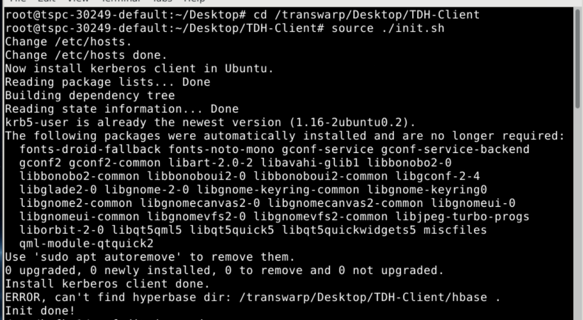

鉴权

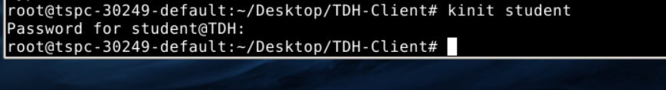

验证

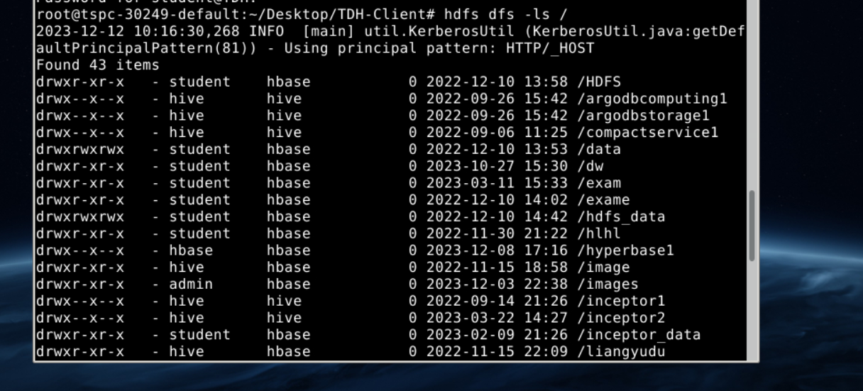

### 1.使用Waterdrop连接Slipstream

打开Transwarp Manager查看集群中Slipstream主节点的Server Host

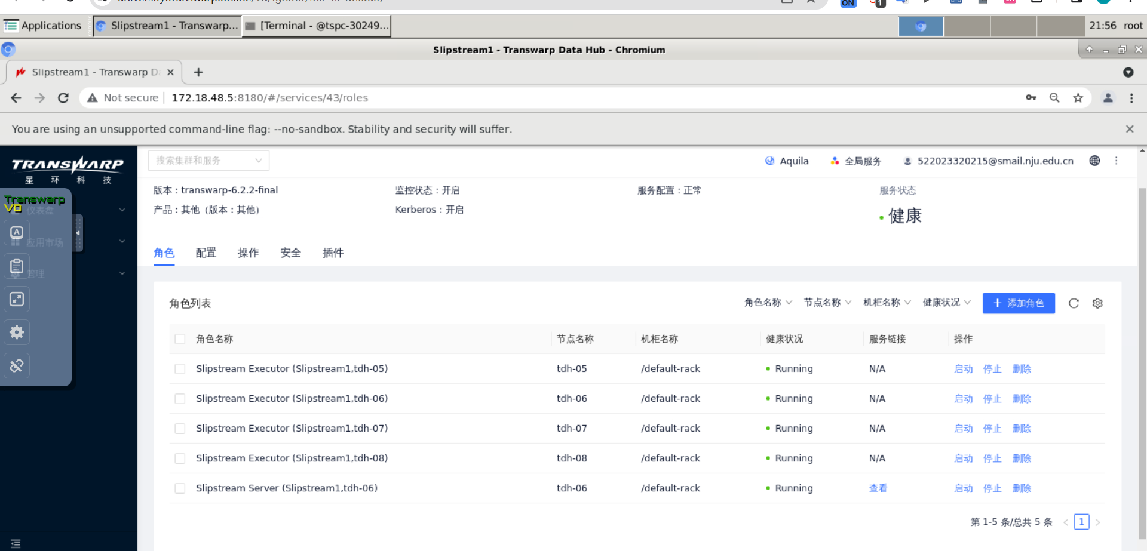

找到里面的server_host

在Waterdrop中建立与Slipstream的连接

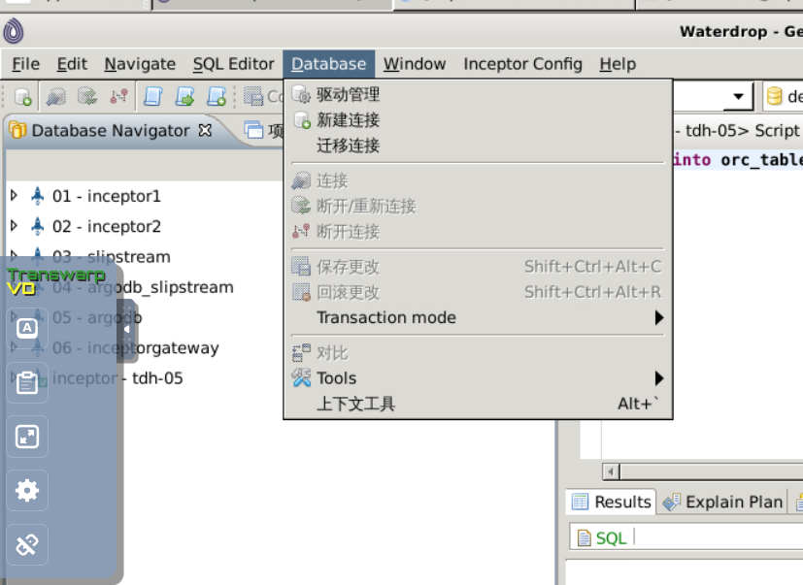

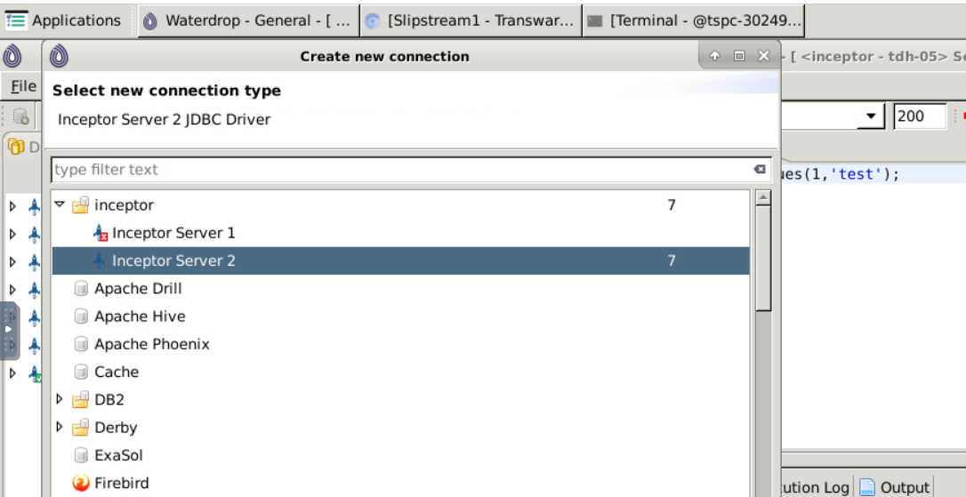

在弹出界面中填写如下信息，其中Server Host为Slipstream主节点地址，之前步骤中已经获取到，Port为10010，Auth Type选择为LDAP，User name为student，Password为123456。

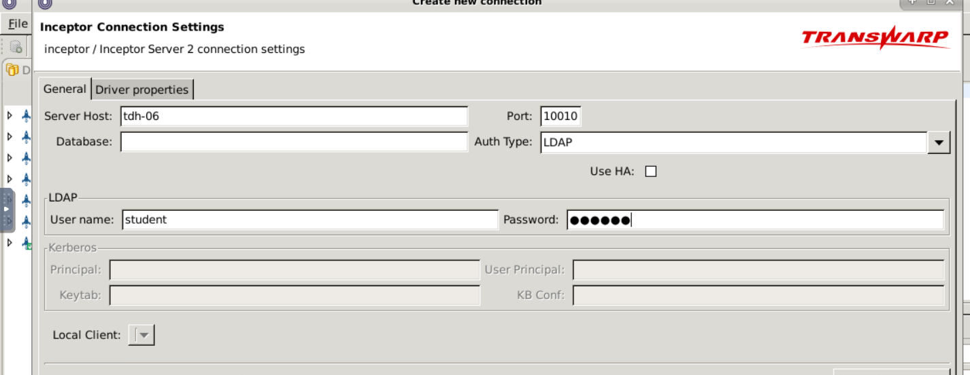

进行连接测试

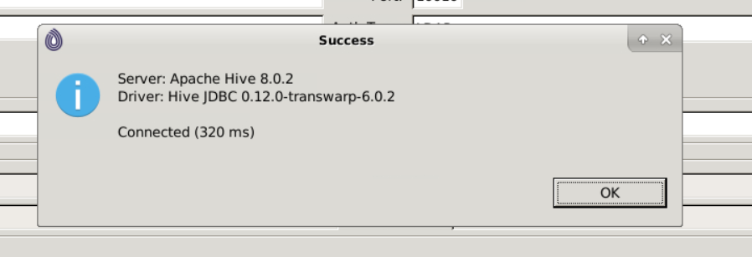

点击Next完成连接操作。

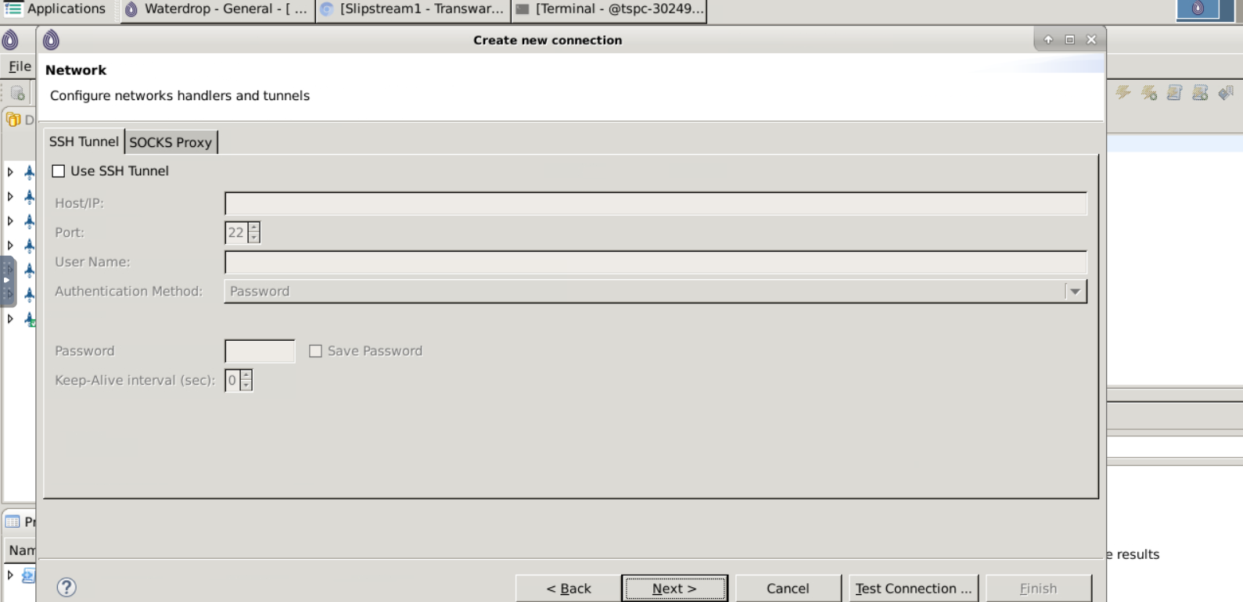 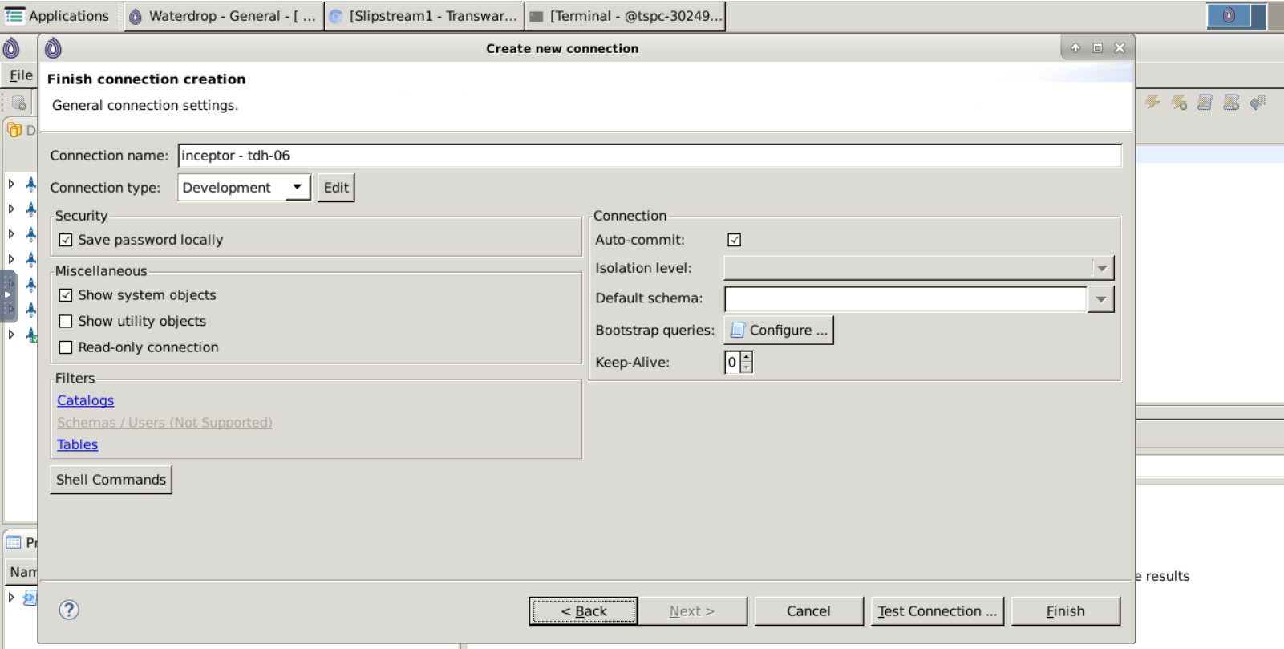

建立与Slipstream的连接，并打开SQL编辑器，之后的SQL操作都在编辑器中完成，编写好SQL后，选中SQL内容，按快捷键Ctrl+回车执行

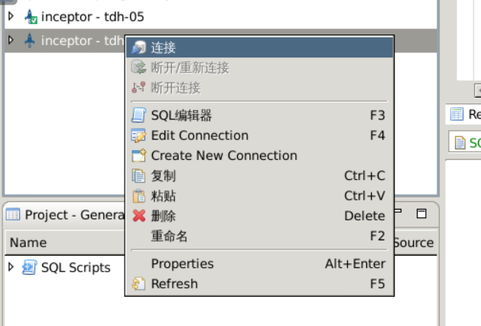

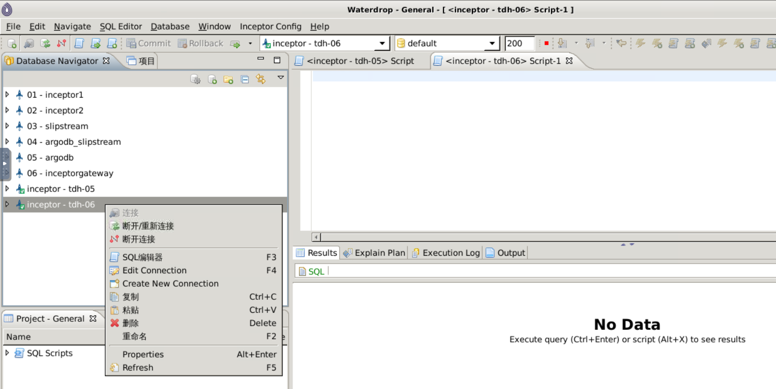

### 2、创建Kafka Topic

cd /transwarp/Desktop/TDH-Client/kafka/bin

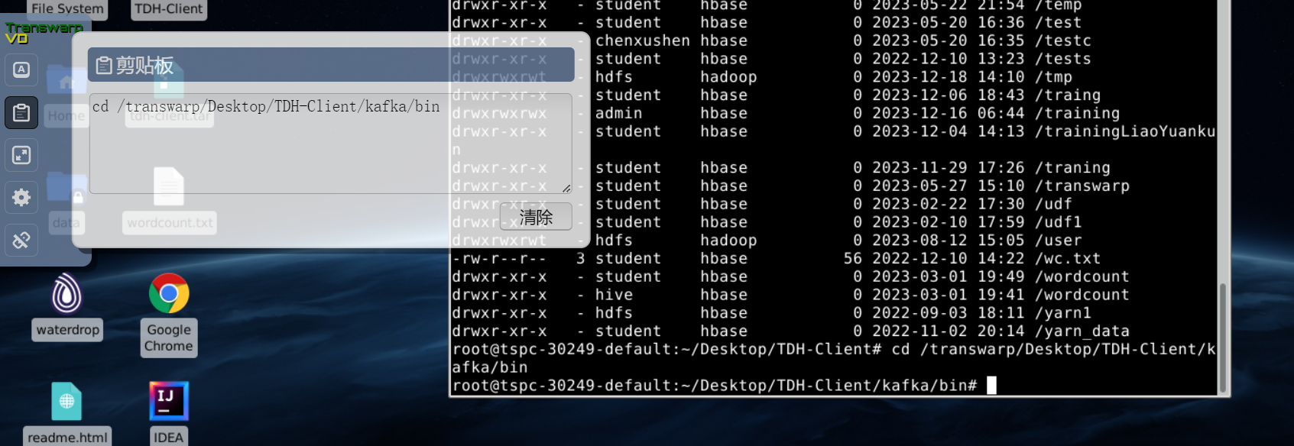

./kafka-topics.sh --bootstrap-server 172.18.48.5:9092, 172.18.48.6:9092 --create --topic topic_log_zhangyu --partitions 3 --replication-factor 2 --command-config /transwarp/Desktop/TDH-Client/kafka/config/consumer.properties

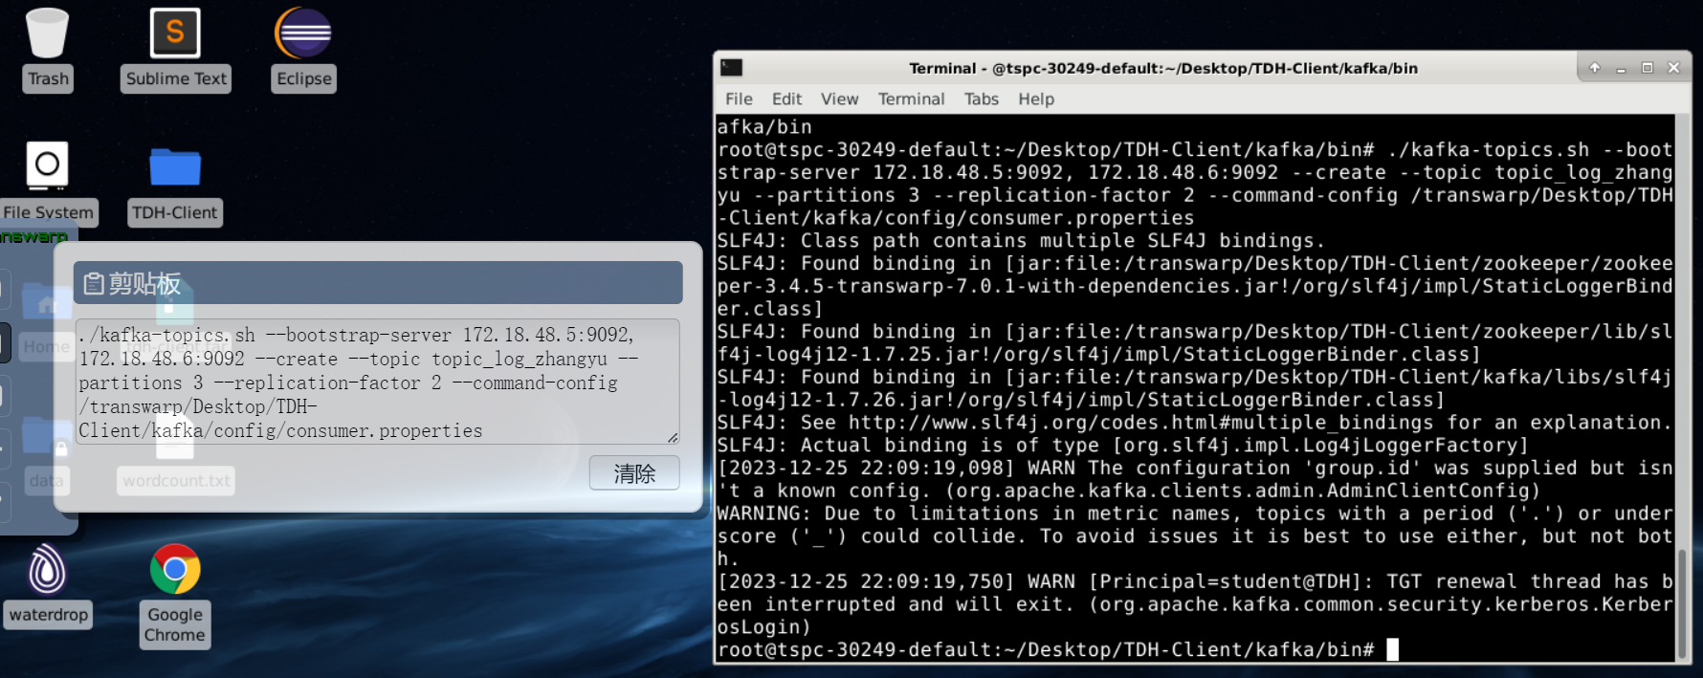

./kafka-topics.sh --zookeeper 172.18.48.5:2181, 172.18.48.6:2181 –list

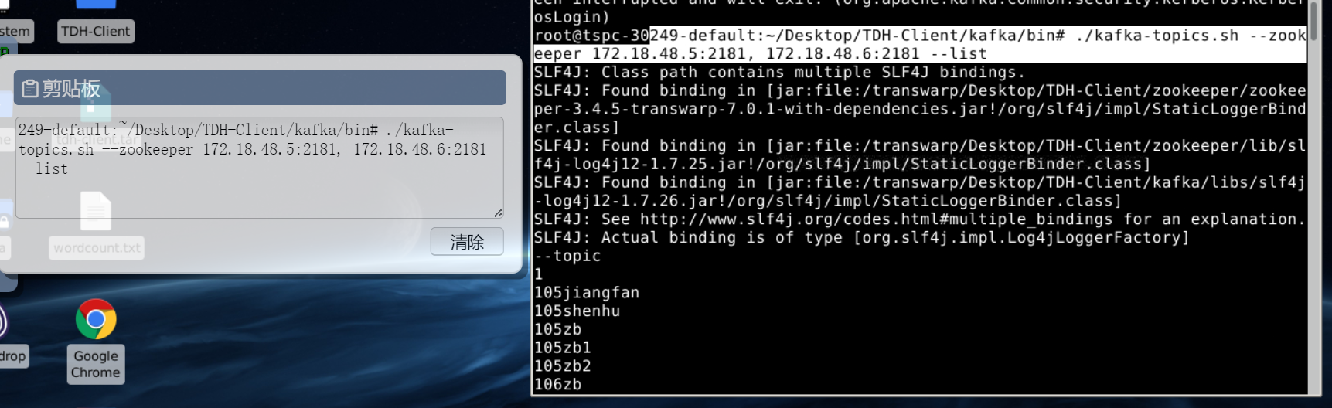

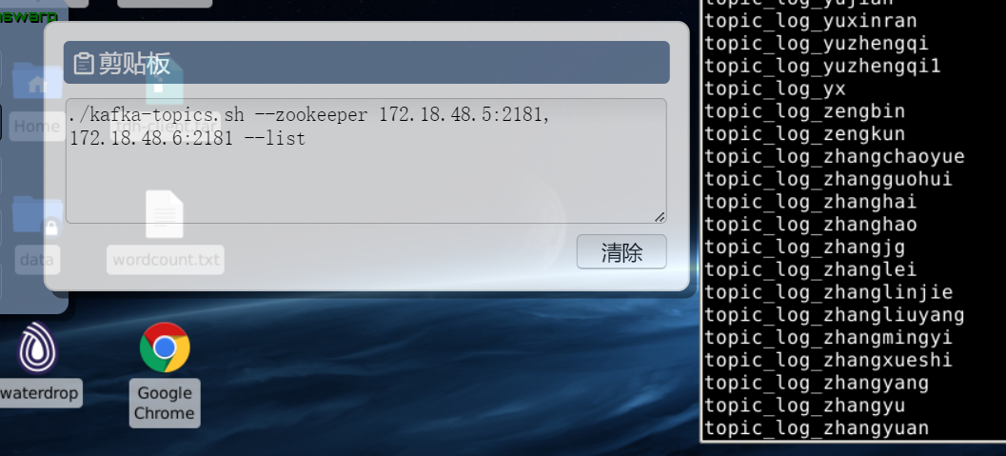

topic_log_zhangyu创建成功

### 3、创建输入流表

use db_zhangyu;

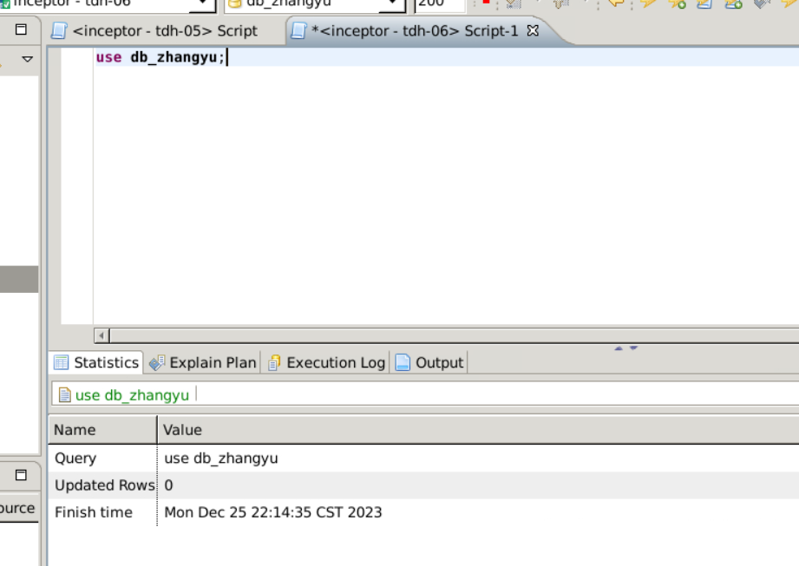

create application app_zhangyu;

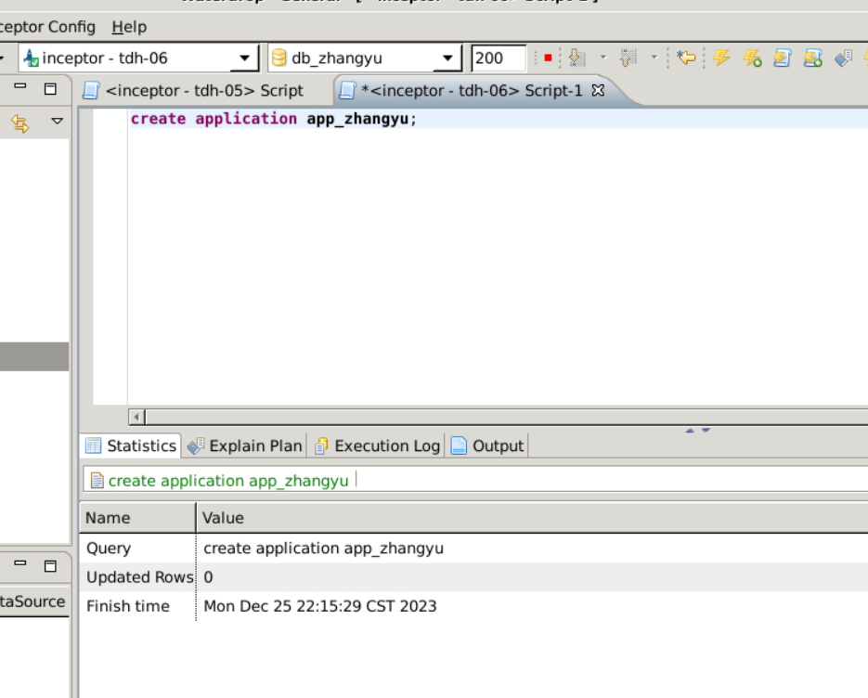

use application app_zhangyu

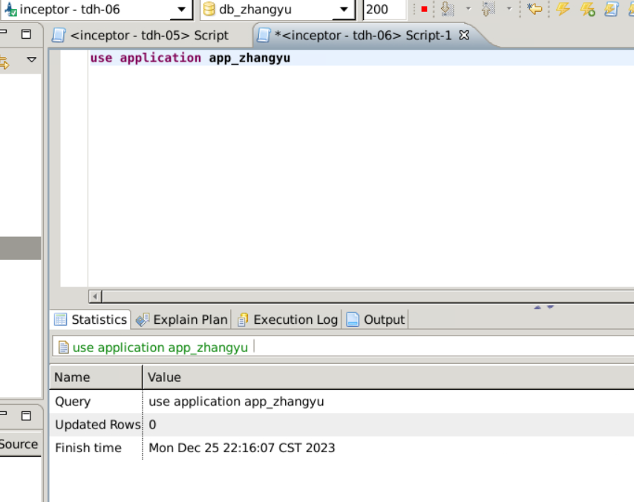

create stream logs (ip string, url string, time timestamp) row format delimited fields terminated by ',' tblproperties( "topic"="topic_log_zhangyu", "kafka.zookeeper"="172.18.48.5:2181, 172.18.48.6:2181", "kafka.broker.list"="172.18.48.5:9092, 172.18.48.6:9092", "transwarp.consumer.security.protocol"="SASL_PLAINTEXT",

"transwarp.consumer.sasl.kerberos.service.name"="kafka",

"transwarp.consumer.sasl.jaas.config"="com.sun.security.auth.module.Krb5LoginModule required useKeyTab=true storeKey=true keyTab=\"/etc/slipstream1/conf/student.keytab\" principal=\"student@TDH\"");

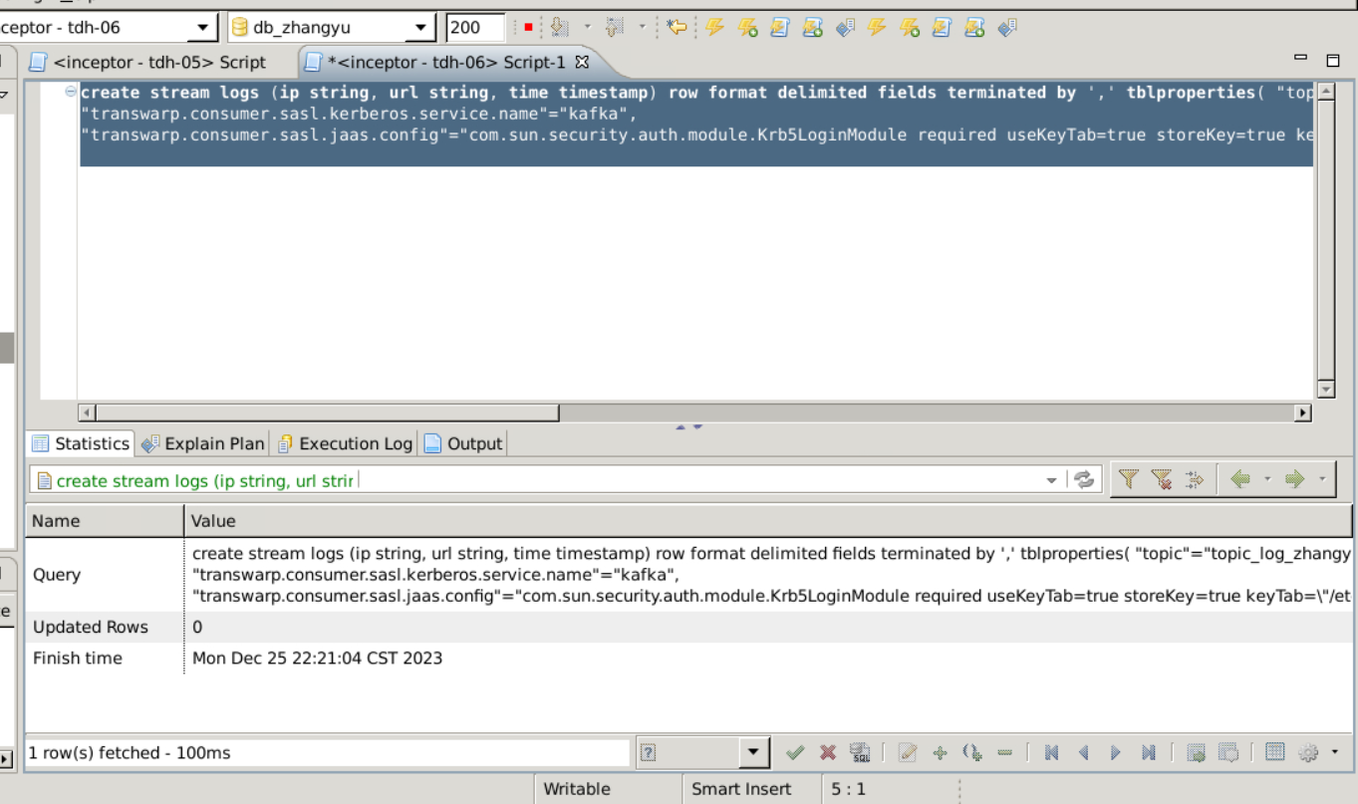

### 4、创建衍生流表

create stream wlog as select * from logs streamwindow sw as (length '10' second slide '10' second);

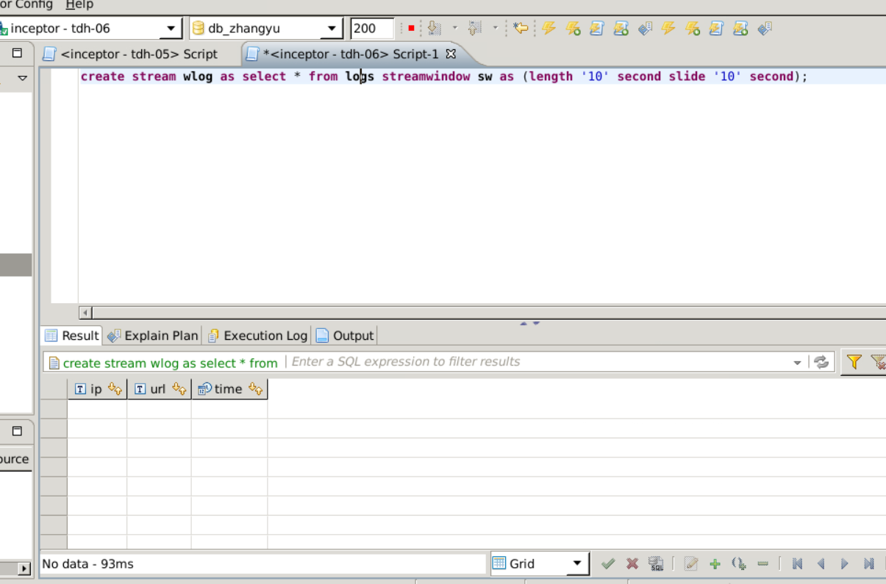

show streams;

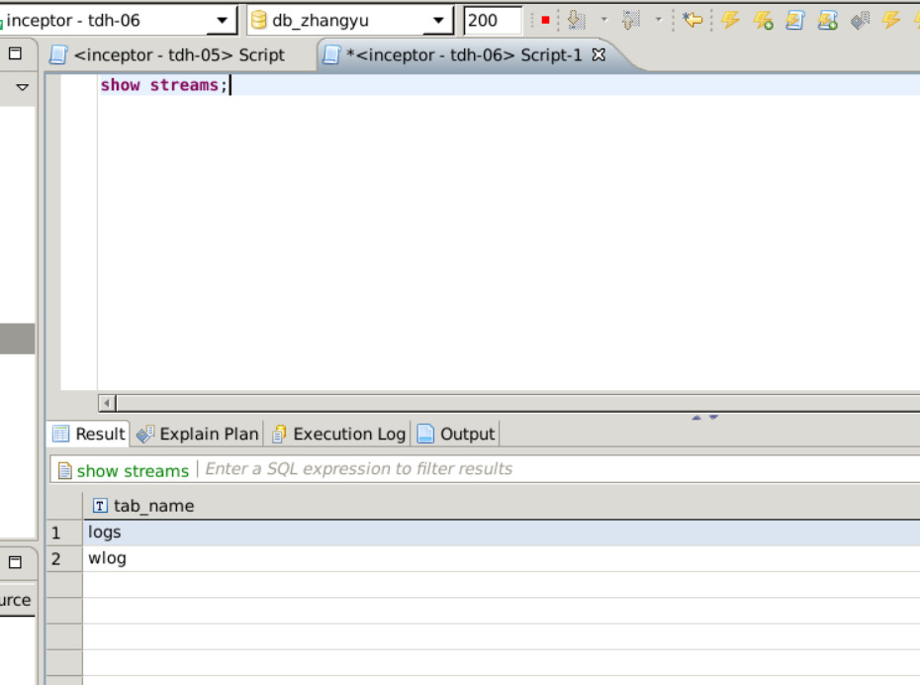

### 5、创建结果表

use db_zhangyu

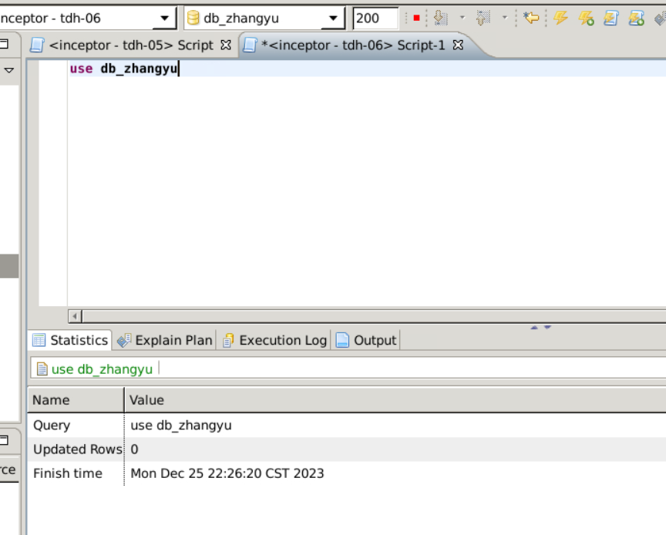

create table result_table(url string, count int);

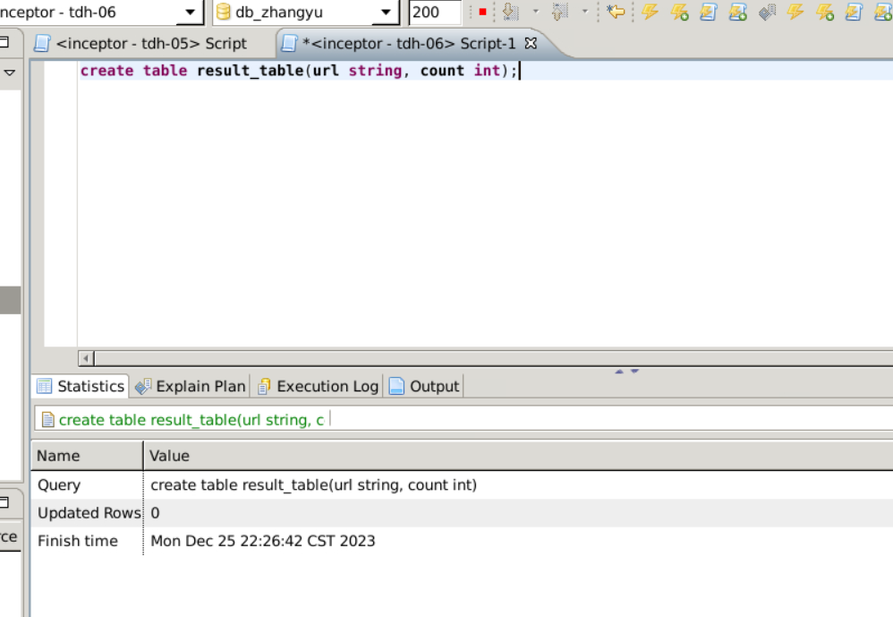

### 6、创建流任务

CREATE STREAMJOB job_zhangyu AS (" insert into result_table select url, count(*) from wlog group by url")JOBPROPERTIES("morphling.result.auto.flush"="true");

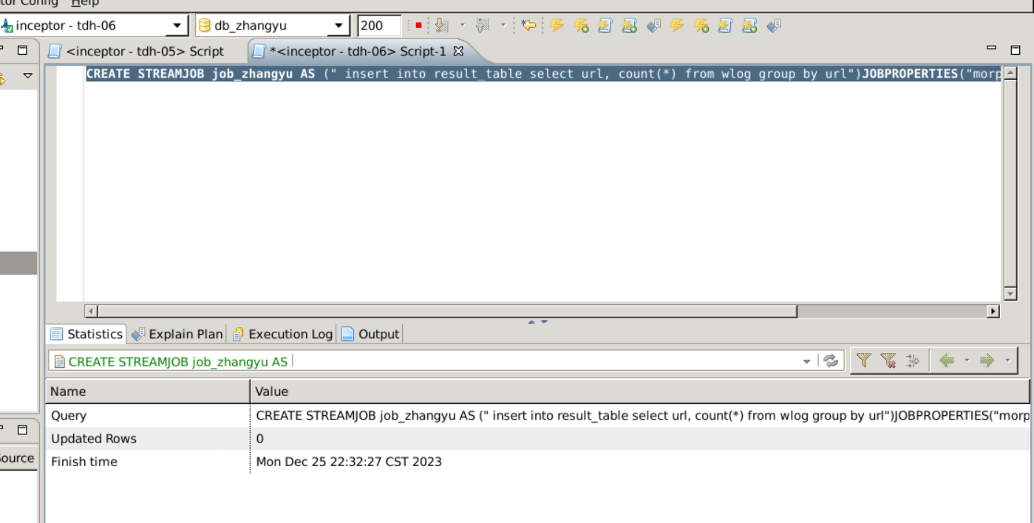

show streamjobs;

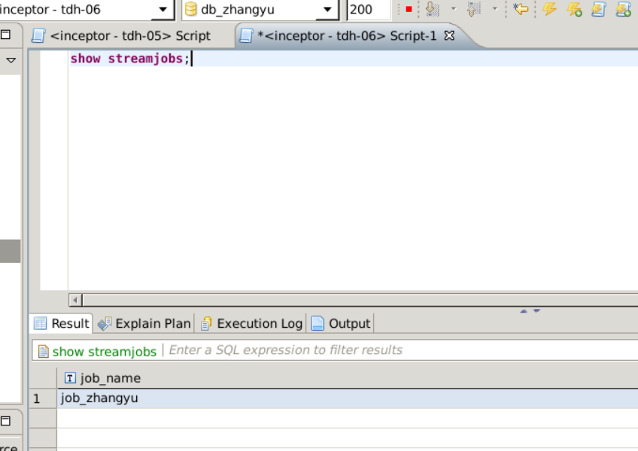

### 7、启动流任务

START STREAMJOB  job_zhangyu;

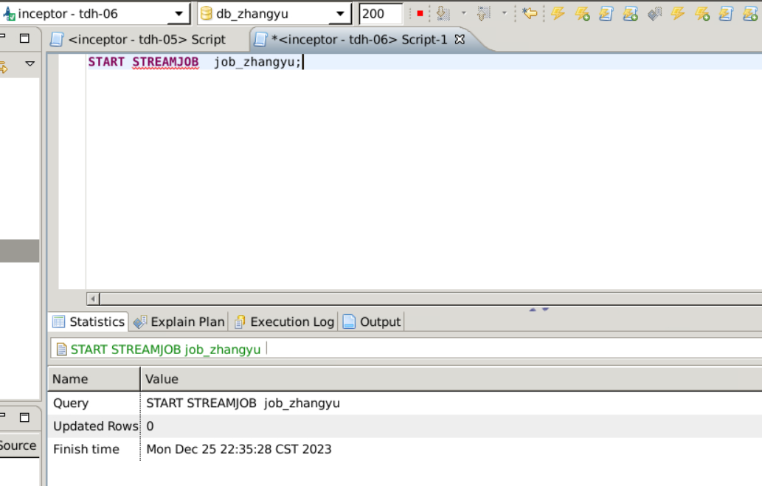

list streamjobs;

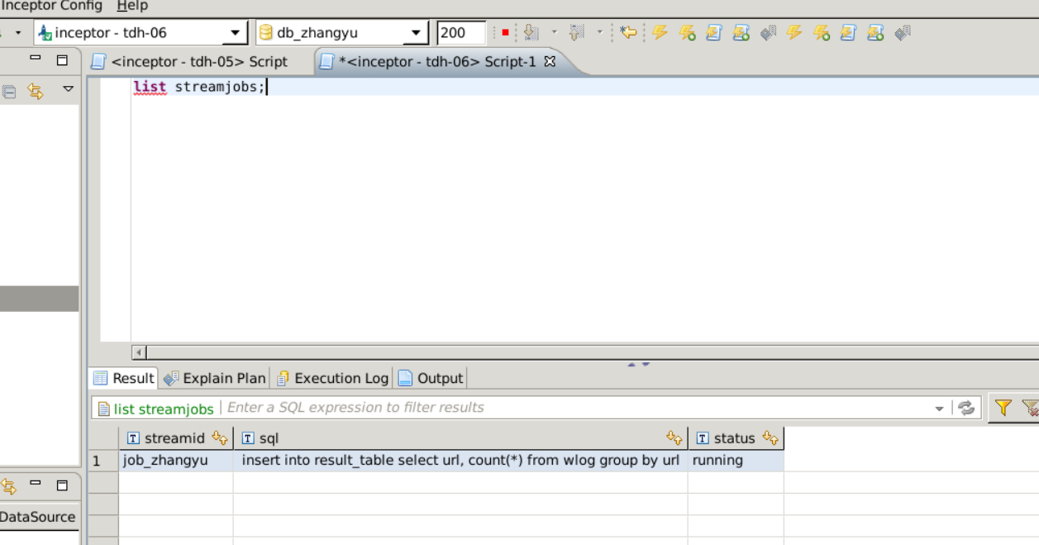

### 8、向Kafka Topic发送数据

source /transwarp/Desktop/TDH-Client/init.sh

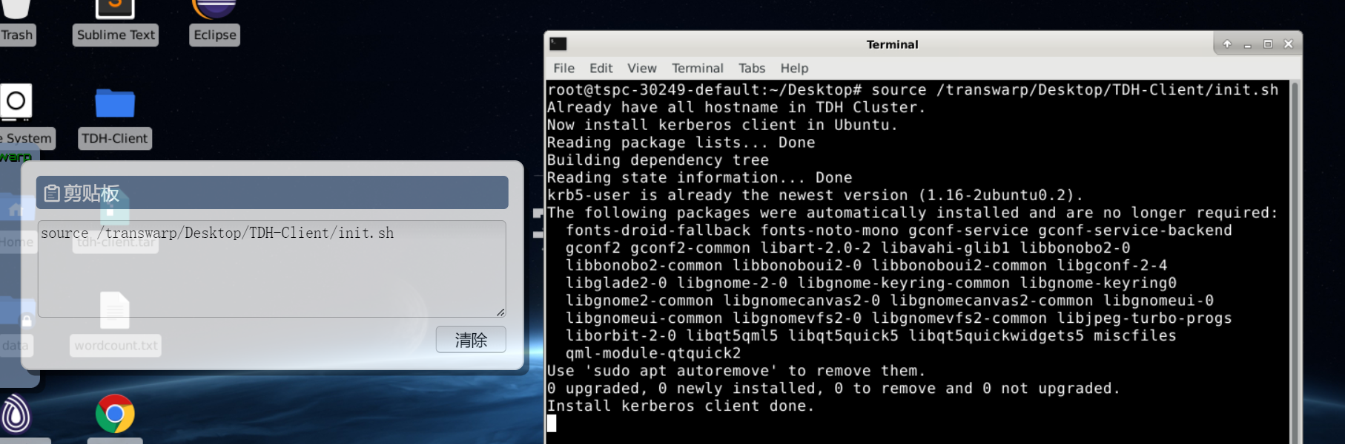

cd /transwarp/Desktop/TDH-Client/kafka/bin

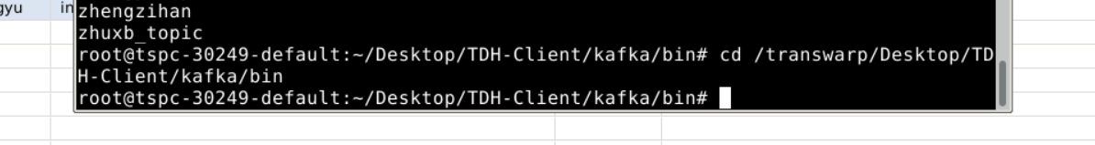

./kafka-console-producer.sh --topic topic_log_zhangyu --broker-list 172.18.48.5:9092, 172.18.48.6:9092 --producer.config /transwarp/Desktop/TDH-Client/kafka/config/producer.properties

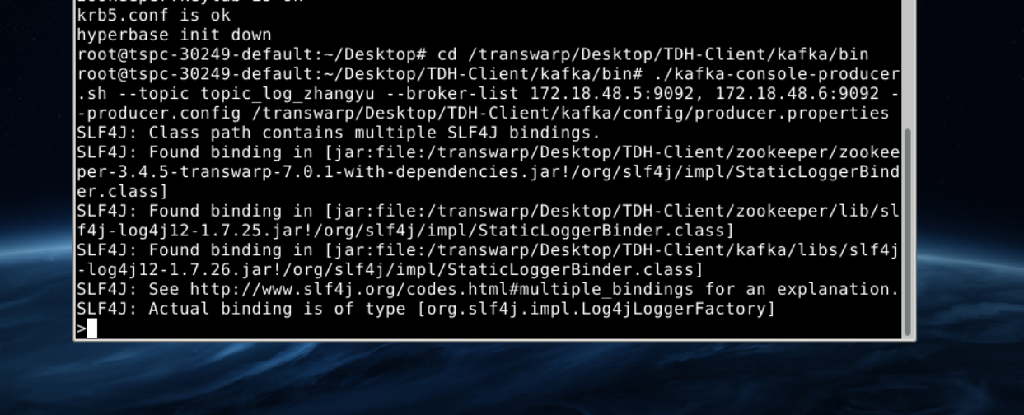

发送给Kafka的实验数据

27.0.1.125,www.transwarp.io/home.html,2016-8-14 20:12:31.132

54.231.66.16,www.transwarp.io/product.html,2016-8-14 20:12:32.132

72.21.203.5,www.transwarp.io/case.html,2016-8-14 20:12:33.132

207.241.224.2,www.transwarp.io/product.html,2016-8-14 20:12:34.132

12.129.206.133,www.transwarp.io/product.html,2016-8-14 20:12:51.132

208.111.148.7,www.transwarp.io/home.html,2016-8-14 20:12:52.132

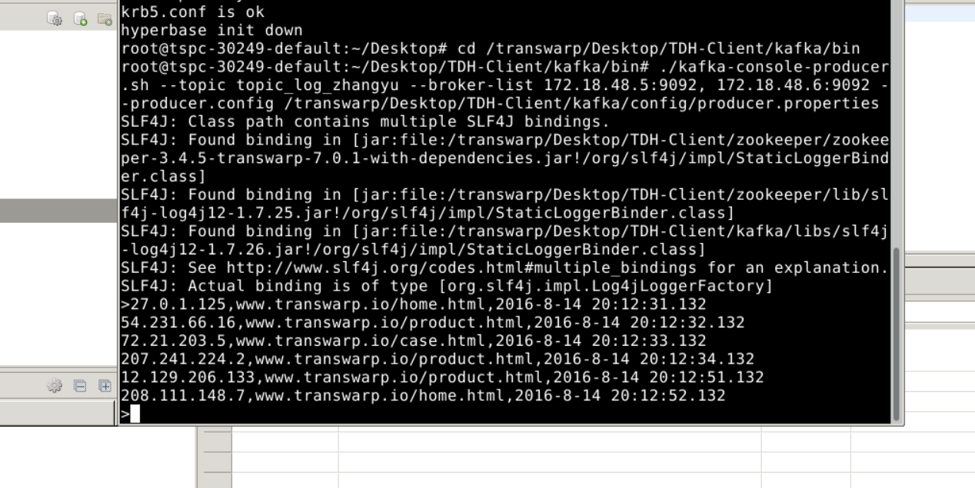

### 9、查看流处理结果

select * from result_table;

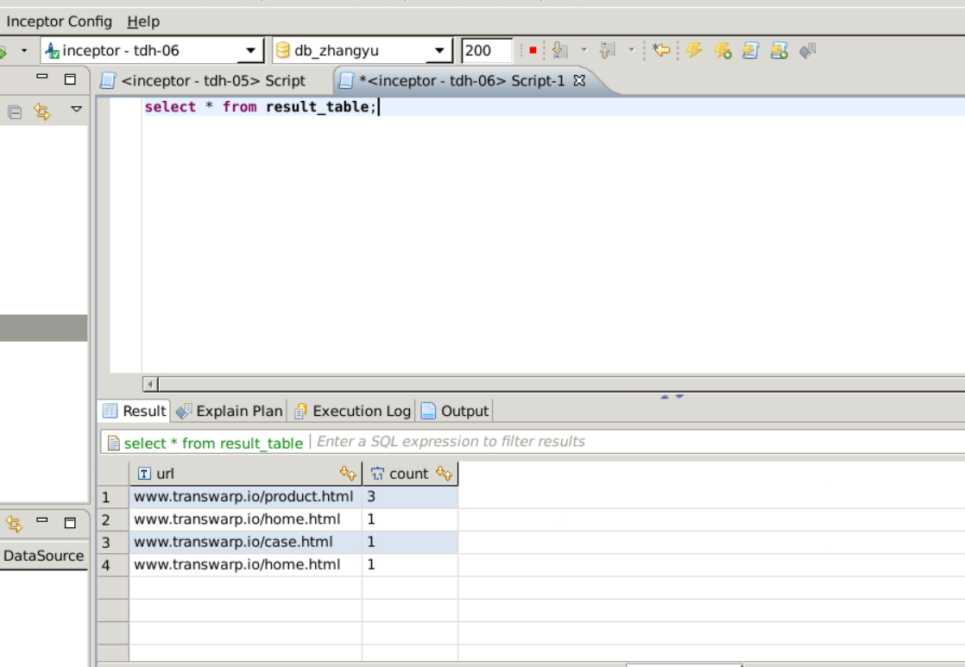

### 10、停止正在运行的流任务

LIST STREAMJOBS;

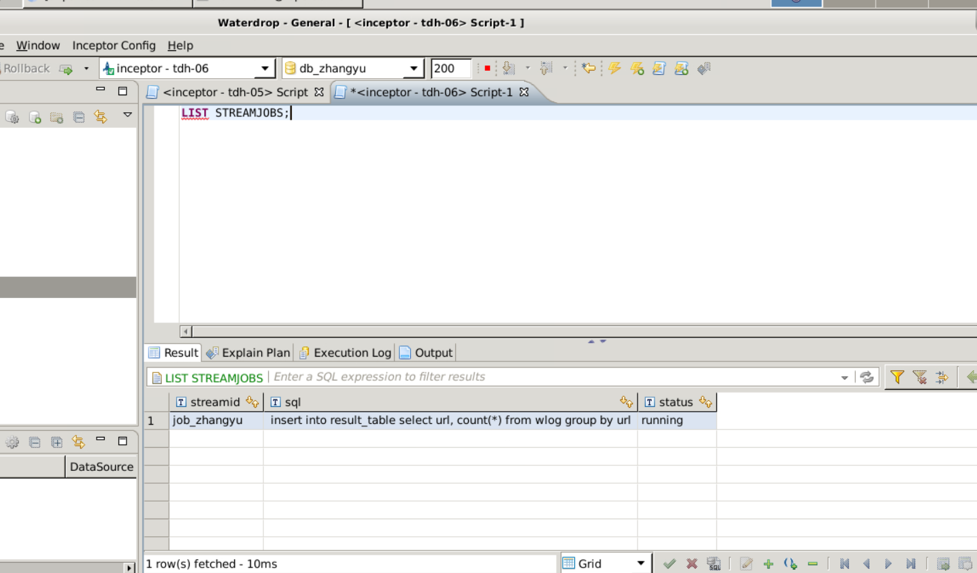

STOP STREAMJOBS;

